CHAPTER 1

INTRODUCTION

I. VISION FOR THURSTON COUNTY
People have chosen to live and work in Thurston County for many reasons. The county provides a diversity of environments and lifestyle choices such as urban, rural, and small town, all within a short distance of one another. The County is a vibrant community that ensures the health, safety, and wellbeing of generations to live, work, and play. The wholesome quality of life offered by the county includes a clean environment, job opportunities, easy access to work, recreation and shopping, regional health facilities, education and cultural activities, a variety of human services and a peaceful, uncrowded atmosphere.
Thurston County is anticipating continued high growth over the next two decades. That growth presents a challenge for the future as the county seeks to maintain and enhance its quality of life while achieving the benefits of growth and minimizing any negative side effects. The vision for Thurston County defines the future toward which the county is moving, and identifies how the county will respond to growth and change. The desired future for the Thurston County community is described in these 6 broad themes from the Thurston County Strategic Plan:
- Thriving Individuals, Families, and Communities: Thurston County is striving to support positive health outcomes for all by addressing the social determinants of health that currently lead to significant health inequities. We will seek to provide access to affordable, adequate, and safe housing for all, as we know that a safe place to sleep is essential for wellbeing and that a loss of well-being can also cause a loss of housing. The County is working to be prepared for emergencies and disasters, with disaster resilient businesses, residents, and County government, as well as a responsive and effective emergency medical services system. Our desired natural environment will support healthy people and communities by providing clean, safe water to drink and air to breathe, as well as access to opportunities for physical recreation and the enjoyment of nature.

- A Prosperous Economy that Benefits All: Thurston County has a diverse economy, including state and local government, national and international trade, agriculture and farming, tourism, and natural resource development. Our desired future economy will offer more equitable access to opportunities for employment and alleviate poverty, with more residents able to find living wage jobs without driving outside the county to reach their place of employment. The County’s long-term planning, infrastructure investments, and direct services support economic development indirectly by serving businesses as well as residents. While the County’s direct investments to support economic development are currently used to fund the work of key partners, our desire is to take a more hands-on and proactive role in shaping the region’s economy in the future.

- A Healthy Natural and Built Environment: Thurston County residents value balancing growth and development with protecting the County’s natural beauty and landscapes. We believe that we can grow in a responsible and sustainable manner through sound planning and effective investment. Our vision is for a thriving, safe, natural environment simultaneous with a healthy, prosperous economy. We are working to be resilient in the face of climate change and contribute to regional efforts to maintain a stable climate.

- Responsive Law, Justice, and Public Safety: We aspire to ensure all residents, business owners, and visitors feel safe anywhere they go in Thurston County. We will continue to prioritize public safety, as well as progressive criminal justice reform and alternative dispute services that reduce the number and disproportionality of individuals entering the justice system and reduce recidivism among those that do.

- Effective County Governance: The County will continue to facilitate fair, secure, and transparent elections to fill elected offices and provide diverse opportunities for community and civic engagement to ensure resident voices are heard. We will continue to provide trusted property assessment and tax collection services and the skillful management of County resources. Ensuring the financial health of the County is a top priority and we will strive to find ways to sustainably fund the core services the County provides for the benefit of all our residents, businesses, and visitors.

- Effective County Organization: The Thurston County organization seeks to deliver the people, resources, capacities, and tools necessary to carry out the roles and responsibilities of government and to provide the level of service our residents deserve. We work both independently and through a rich and collaborative network of regional partnerships. We are striving to achieve robust communications and secure information technology systems to connect offices and departments across the County; clean, efficient, and safe facilities that serve employees and customers well; and the retention and cultivation of our most critical resource: a highly qualified and dedicated workforce.

- As Thurston County grows, the community is becoming more diverse. Growth in the community changes the Countys racial demographics, age of the population, and average household size and income.

As an overarching concept, the County supports access to opportunities for all, regardless of gender identity, sexual orientation, age, race, income, or address, and strives to diminish inequities in health outcomes, access to housing, economic opportunities, and a healthy environment, and envisions a diverse community where everyone who lives, works, and plays in the county can experience a culture of equity, inclusivity, and belonging where everyone can thrive. The County commits to pursuing systemic change by promoting equity, inclusion, and diversity in all aspects of county government, and believes that embracing equity enhances our community for all its residents.

II. 2025 Community Priorities and Visions
As part of the 2025 Comprehensive Plan Update, Thurston County conducted outreach to the community to identify their top priorities over the next twenty-year planning period (2022 survey), as well as their vision for the Thurston County community (2023 survey).

A. 2022 Community Priorities survey
A survey held in fall and winter of 2022 asked community members what their top priorities and concerns were over the next 20 years. The survey was available in 4 languages (English, Spanish, Vietnamese, and Korean), and widely disseminated through direct e-mails, news releases, outreach to BIPOC and multi-cultural organizations, social media posts in several languages, and flyers posted in over 40 locations across Thurston County. Over 950 people took the survey, with most individuals residing in zip codes that overlapped the Olympia, Lacey, and Tumwater areas. The following topics rose to the top of respondent’s picks:
- Protect sensitive areas like wildlife habitat, flood areas, landslide areas, and surface and ground water (57% of respondents).
- Prepare for climate change and take action to reduce impacts (47% of respondents).
- Protect agriculture (36% of respondents).
- Increase availability of affordable housing (33% of respondents).
Other important topics of the community included diversifying and increasing job and business opportunities, preparing for natural hazards, addressing traffic congestion, improving access to health care, protecting cultural and historic resources, and improving equity and fairness in the community.

B. 2023 Community Visioning Survey
A survey held in from May through December of 2023 asked community members a series of open response questions to help identify community visions for the next 20 years. The survey was available in 4 languages (English, Spanish, Vietnamese, and Korean), and widely disseminated through direct e-mails, news releases, outreach to BIPOC and multi-cultural organizations, social media posts in several languages, and advertised during over 24 stakeholder-requested presentations across the County. Over 500 people took the survey, with most individuals residing in zip codes that overlapped the Olympia, Lacey, and Tumwater areas.
- When asked what comes to mind when thinking about Thurston County, the following themes were the most common: environment, clean water, beauty, community, unhoused population, growth challenges, state capitol, crime, rural.

- When asked what individuals enjoy currently about Thurston County, the following themes were the most common: parks and outdoor activities, environment/natural beauty, community events/cultural activities, rural living, agriculture/farmers markets.

- When asked what is currently missing from Thurston County, the following themes were the most common: recreation and activities for all ages, affordable housing, public/alternative transportation, less crime/safety, natural resource protection, response to unhoused population, healthcare access.

- When asked what the biggest challenges they’re facing right now are, the following themes were the most common: affordable housing, climate change, environment, clean water, cost of living, crime, growth challenges, taxes, traffic, preservation of agriculture and open spaces.

- When asked what their ideal community looks like, the following themes were the most common: protected environment/green spaces, affordable housing for all, public transportation, less or no crime, less unhoused, more parks, more agriculture, managed growth with population densities, more diverse and inclusive activities for all ages, good healthcare.

III. AUTHORITY FOR PLANNING
Thurston County adopts this Comprehensive Plan under the authority of the Washington State Growth Management Act (GMA), RCW 36.70A. Other legislation, including the Planning Commission Act (RCW 35.63), provide additional authority for and the procedures to be followed in guiding and regulating the physical development of the county.
GROWTH MANAGEMENT GOALS

The following goals from the Act (RCW 36.70A.020) are used to guide the development and adoption of this Comprehensive Plan and its associated development regulations:
- Urban growth. Encourage development in urban areas where adequate public facilities and services exist or can be provided in an efficient manner.
- Reduce sprawl. Reduce the inappropriate conversion of undeveloped land into sprawling, low-density development.
- Transportation. Encourage efficient multimodal transportation systems that will reduce greenhouse gas emissions and per capita vehicle miles traveled and are based on regional priorities and coordinated with county and city comprehensive plans.
- Housing. Plan for and accommodate housing affordable to all economic segments of the population of this state, promote a variety of residential densities and housing types, and encourage preservation of existing housing stock.
- Economic development. Encourage economic development throughout the state that is consistent with adopted comprehensive plans, promote economic opportunity for all citizens of this state, especially for unemployed and for disadvantaged persons, and encourage growth in areas experiencing insufficient economic growth, all within the capacities of the state’s natural resources, public services, and public facilities.
- Property rights. Private property shall not be taken for public use without just compensation having been made. The property rights of landowners shall be protected from arbitrary and discriminatory actions.
- Permits. Applications for both state and local government permits should be processed in a timely and fair manner to ensure predictability.
- Natural resource industries. Maintain and enhance natural resource-based industries, including productive timber, agricultural, and fisheries industries. Encourage the conservation of productive forest lands and productive agricultural lands and discourage incompatible uses.
- Open space and recreation. Retain open space and green space, enhance recreational opportunities, enhance fish and wildlife habitat, increase access to natural resource lands and water, and develop parks and recreation facilities.
- Environment. Protect the environment and enhance the state’s high quality of life, including air and water quality, and the availability of water.
- Citizen participation and coordination. Encourage the involvement of citizens in the planning process, including the participation of vulnerable populations and overburdened communities, and ensure coordination between communities and jurisdictions to reconcile conflicts.
- Public facilities and services. Ensure that those public facilities and services necessary to support development shall be adequate to serve the development at the time the development is available for occupancy and use without decreasing current service levels below locally established minimum standards.
- Historic preservation. Identify and encourage the preservation of lands, sites, and structures that have historical or archaeological significance.
- Climate change and resiliency. Ensure that comprehensive plans, development regulations, and regional policies, plans, and strategies under RCW 36.70A.210 and chapter 47.80 RCW adapt to and mitigate the effects of a changing climate; support reductions in greenhouse gas emissions and per capita vehicle miles traveled; prepare for climate impact scenarios; foster resiliency to climate impacts and natural hazards; protect and enhance environmental, economic, and human health and safety; and advance environmental justice.
- Shoreline management. Address the goals and policies of the Shoreline Management Act (RCW 36.70A.480 & RCW 90.58.020).

IV. How The COmprehensive Plan is Used By Thurston County

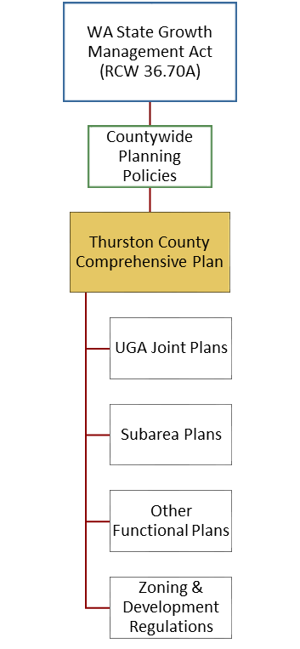
A. The Comprehensive Plan, Joint Plans and Other Specialized Plans
The content of the Comprehensive Plan is guided by the Growth Management Act and the Thurston County County-Wide Planning Policies, a regional framework adopted by the Board of County Commissioners, in collaboration with the seven cities and towns within Thurston County.
The Comprehensive Plan contains goals and policies to govern the unincorporated areas of Thurston County. In turn, the Plan guides several other kinds of specialized plans: joint plans, subarea plans, and functional plans. Map I-1 shows Thurston County jurisdictional boundaries.

Joint Plans
Joint plans serve as the Comprehensive Plans for the unincorporated areas within the urban growth boundaries for the cities and towns within the county. They are integral parts of this Comprehensive Plan, although they appear in separate documents. Joint plans are further discussed in Chapter 2 – Land Use.

Subarea Plans
Subarea plans are detailed plans for specific geographic areas of the county. These types of plans are discussed in Chapter 2 – Land Use.

Special Purpose (Functional) Plans
Functional plans cross subarea or urban growth boundaries and pertain to a certain subject such as sewers, stormwater, open space, or historic resources. As with the subarea plans, functional plans use goals and policies and the urban-rural framework from the Comprehensive Plan to guide their development and implementation. Examples of functional plans include the Transportation Improvement Plan, Stormwater Management Program Plan, and the Parks, Open Space and Trails Plan. Some of these plans are developed for the county as a whole; others apply to parts of the county.
Figure 1-1. Planning Hierarchy

- See Chapter 2 – Land USe for goals, objectives, and Policies on the County’s Planning System
- See Appendix C for a List of Related Plans

B. The Role of the Comprehensive Plan
The Comprehensive Plan provides a legally recognized framework for making decisions about land use in Thurston County. The Plan directs the county’s future physical growth through several mechanisms.
Guidance for Development Regulations. The County’s development regulations, such as the zoning ordinance, must be consistent with the policies in this Comprehensive Plan.
Guidance for Capital Facilities Planning. The County’s Capital Facilities chapter and Capital Improvement Program must include the public facilities needed to accommodate the population growth anticipated in the Comprehensive Plan. It also must ensure that levels of service adopted within the Plan can be maintained. Secondly, the Comprehensive Plan provides the framework for decisions about public facilities and services (such as where facilities should be located to support planned growth).
Guidance for Specific Land Use Permit Applications. In reviewing applications for land use permits, such as special use permits or large residential developments, the staff or hearings examiner refer to the Comprehensive Plan or more specific related plans, such as joint plans, in determining whether the application should be approved.
Guidance for Related Plans. Plans that are adopted by reference within this Comprehensive Plan (see discussion of joint plans and specialized plans below) must be consistent with the policies contained within this Plan, which serve as the overall framework for all County land use policies.
Guidance for Related Inter-Local Agreements. Occasionally the County and other jurisdictions within the County enter into voluntary agreements for various purposes, such as to coordinate policies of mutual interest, the use of shared facilities, and the accomplishment of mutual goals. Examples include annexation agreements with cities and the LOTT agreement for the regional sewage treatment facility. Such agreements are useful tools for implementing Comprehensive Plan policy when interjurisdictional cooperation is necessary or just more efficient.
Guidance for Various County Programs. Many of the policies within this Plan refer to County programs or projects needed to fulfill the goals of the Plan, such as the Purchase of Development Rights program.

C. Time Horizon
The Comprehensive Plan is meant to be a long-term guide for development in the county. The GMA requires the county to plan for and accommodate the population growth projected over the next 20 years. This plan shows how the county will accommodate the 20-year projected growth. In determining the extent and distribution of uses permitted on the land, this plan focuses primarily on the physical characteristics of the land. To assure that the Comprehensive Plan, joint plans, and subarea plans keep pace with any changing conditions and community desires, periodic review and evaluation of the land use designations and policies should be undertaken.

V. HOW THIS DOCUMENT IS USED BY OTHERS
Besides guiding the County’s own decisions, this plan is intended to aid a broad range of public and private users, including community groups, builders, developers, Thurston County officials and other government agencies.
- It Informs the Public: As the framework for other plans and regulations that govern the location and intensity of land uses throughout unincorporated Thurston County, the plan indicates, in a general sense, how and where development will change the County’s landscape. The plan also indicates to the public how likely Thurston County would be to approve changes in plans, zoning, or other regulations that apply to an area or a specific parcel.
- It Informs Other Public Entities: It is intended that cities and other public agencies use the Comprehensive Plan as they develop plans and make project decisions. The cities, in cooperation with Thurston County, will use the plan in updating their own comprehensive plans, growth policies, joint plans with the county and proposals to annex county territory. Federal, state, and regional agencies also will use the plan in making project decisions. Special districts, such as school and fire districts, use the plan in preparing their functional plans for delivering services.
- Why It Uses “Should” Instead of “Shall”: The Comprehensive Plan is a broad policy document intended to guide more specific land use decisions in the future. Regulations, such as zoning and building codes or road construction standards, are detailed rules applied uniformly, with little discretion. Therefore, although the Comprehensive Plan carries legal weight when applied to specific land use decisions, it uses the word “should” rather than the nondiscretionary “shall” found in regulations.

VI. HISTORY OF AMENDMENTS TO THE COMPREHENSIVE PLAN
Thurston County’s first Comprehensive Plan was adopted in 1975. This initial plan set the stage for the introduction of countywide zoning and environmental protection regulations—critical features of land development in that period of very high population growth; the County’s population grew by more than 60 percent during the 1970’s. The 1975 Plan also introduced policies for economic development, the provision of public services, transportation, natural resource protection, and other features typical of comprehensive plans.
The first major overhaul of the Comprehensive Plan was adopted in 1988 after four years of preparatory work, extensive public review, and policy development. Among the changes introduced in 1988 was a greater emphasis on concentrating population growth in existing urban areas where the necessary public services and facilities could be provided more cost-efficiently. That plan included the State’s first urban growth management boundaries which were established for the north county cities. Another innovative approach to growth management in the Plan was the concept of joint planning between the County and cities. Joint planning enabled the County to better coordinate land development policies in areas likely to be annexed by cities or towns in the foreseeable future. This early experience with coordinated, cooperative planning with its neighboring jurisdictions put the County ahead of the pack when the Growth Management Act was passed in 1990, requiring coordination in planning.
The 1988 planning process also involved a close examination of natural resource lands issues, particularly, how best to preserve scarce agricultural lands and forest lands. These proved to be difficult issues to address. The 1988 Plan added detail to the County’s housing strategies, included a chapter on Historic Resources, reinforced economic development efforts, and expanded policies to correspond to increasing information about environmental protection needs. The Plan stepped up the County’s sophistication in public services and facilities planning, paying attention to maximizing efficiencies and reducing costs. While the 1975 Plan’s transportation chapter focused on needed road improvements, the 1988 Plan recognized the relationship between land use and a variety of transportation needs. In summary, the 1988 Comprehensive Plan left the County well-positioned to respond to the requirements of the 1990 Growth Management Act, whereas many jurisdictions were required to make quantum leaps in policy direction in a very short timeframe.
The 1995 update of the Comprehensive Plan brought the Plan into full compliance with the Growth Management Act (GMA). All the changes made were either to respond to GMA requirements or to update the 1988 material. The work needed to comply with the GMA began with the adoption of County-Wide Planning Policies (by the cities and county) to ensure a consistent planning approach throughout the County. Next came the classification and designation of natural resource lands, moving forward in an area of high importance and interest in Thurston County. That work was integrated into a rural zoning analysis that resulted in a stronger delineation of urban lands from rural lands in the County’s zoning regulations, also required under the GMA. At the same time, the County developed the GMA-required critical areas ordinance for the protection of important and vulnerable environmental features. Additional chapters of the plan were added to comply with the elements required under GMA.
Under the framework of the County-Wide Planning Policies, the County developed joint plans with each city and town that proposed an urban growth area that extends into the unincorporated county. Joint Plans provide the Comprehensive Plan for these urban growth areas and are adopted as a part of this Comprehensive Plan, although they appear in separate documents.
The 1995 Comprehensive Plan was developed in the context of the timelines provided under the GMA. Public participation improved the direction of the Plan through comments made at open houses held both at the beginning of the Plan development, and after the first draft was reviewed by the Thurston County Planning Commission. Public hearings were held before both the Planning Commission and the Thurston County Board of Commissioners to further involve the public in the Plan’s development. Separate joint plan adoption processes provided additional opportunities for the public to direct the County’s growth.
In 2003, major amendments to Chapter 3 – Natural Resource Lands and Chapter 9 – Environment, Recreation, and Open Space updated county policies for natural resource protection. The 2004 amendments to the Comprehensive Plan and associated development regulations updated the remaining chapters of the plan under the GMA. In 2007, Chapter 2 – Land Use was further updated for GMA compliance.
The 2019 periodic update included revised goals and policies to address affordable housing, transportation, including bicycle and pedestrian infrastructure. This update also included major amendments to Chapter 8 – Economic Development.
The 2025 periodic update included major amendments to reflect legislative changes around planning for affordable housing to all income brackets, and incorporation of climate mitigation and resiliency measures. Additionally, a new implementation appendix was developed with this update. Other amendments across the plan included updates to population projections, building intensities, housing needs, levels of services, consideration of a new agricultural zone for rural Thurston County, and policies across the plan impacting transportation, land use, environment, housing, historic resources, and more.
The Comprehensive Plan is periodically amended according to an annual amendment process and a ten-year review cycle required by the Growth Management Act (RCW 36.70A.130). Annual and periodic reviews ensure that the Plan keeps pace with changing legal requirements and community needs. The plan amendment process is described in Chapter 12 – Plan Amendments.
The participation of the County’s community in shaping the County’s physical and social landscape has been, and will continue to be, the most important feature of Thurston County’s planning history.

VII. SETTING

A. Geography & Climate
Thurston County may experience increasing impacts in the coming decades:
Temperature
Average temperature in the Puget lowlands has increased by 1.3˚ F since the 1890s and could increase an additional 4-6˚ by the 2050s. The hottest days could be 6.5 degrees warmer than currently.
Precipitation
Warmer winters could lead to less snowfall in upper elevations like the Black Hills, and rainstorms of greater intensity. The number of heavy rain events in the winter could increase from two days per year to seven. In the summer, rainfall may decrease by 22%, leading to drier conditions.
Sea-Level Rise
Rising sea levels could flood low-lying areas, particularly during storms and high tides, and permanently inundate the Nisqually Estuary.
Source: Thurston Climate Adaptation Plan: Vulnerability Assessment (TRPC, 2016)
Impacts of a CHanging Climate
Thurston County, situated at the southern end of Puget Sound, includes landforms varying from coastal lowlands in the north county, to cascade foothills in the southeast (See Map I-2). Generally, the county is a region of prairies and rolling lowlands, broken by minor hills and a few peaks which rise to elevations of about 2,600 feet. There are over 90 miles of Puget Sound coastline, three major river basins, and over 100 lakes and ponds in Thurston County.
The county contains a total area of 737 square miles, or 471,713 acres. Approximately 688 square miles (440,545 acres), or 93 percent of the total area, lies in unincorporated Thurston County. The remaining seven percent is divided among the seven incorporated cities and towns of Olympia, Lacey, Tumwater, Bucoda, Rainier, Tenino, and Yelm (See Map I-1). Timber harvest and other natural resource uses historically covered much of the region, and still dominate land use across rural parts of the county (See Map I-3). Residential uses spread from urban areas along transportation routes, up through the Puget Sound peninsulas in the northern end of the county, and around many lakes. Major landowners in the unincorporated county include the State of Washington (including Capitol Forest), the federal government (including Joint Base Lewis-McChord and Nisqually Wildlife Refuge), and private timber companies.
Thurston County’s climate is influenced by Puget Sound and the marine air masses that move through the region from the Pacific Ocean. Summers are warm and generally dry, while winters are mild and wet. Yearly rainfall averages vary across the county; they are highest in the northwest at up to 90 inches per year near Summit Lake and decrease towards the southeast to about 40 inches per year around Lake Lawrence. Mean annual temperature in Olympia is 50.5 degrees Fahrenheit.
Summer temperatures have been steadily increasing while average humidity has been decreasing over the past two decades. Precipitation patterns have temporally shifted from October – April to November -May over the last twenty years; however, overall precipitation quantity has not appreciably changed. The changes identified over the past 10-20 years have resulted in increased summer wildfire hazards and, conversely, decreased streamflow and groundwater levels. These trends are consistent with the Global Forecast System Model relating to climate change impacts for the Pacific Northwest.
The effects of climate change, already observable in 2023, will have an increasing impact through the 20-year planning horizon and beyond (see sidebar). Locally, Thurston County is vulnerable to impacts from warmer summers, winters, and water temperature, increasing drought, intensifying precipitation, sea-level rise, and population change related to climate-driven migration.

B. Population & Demographics
More information on Thurston County Population data is available in The Profile updated annually by Thurston Regional Planning Council
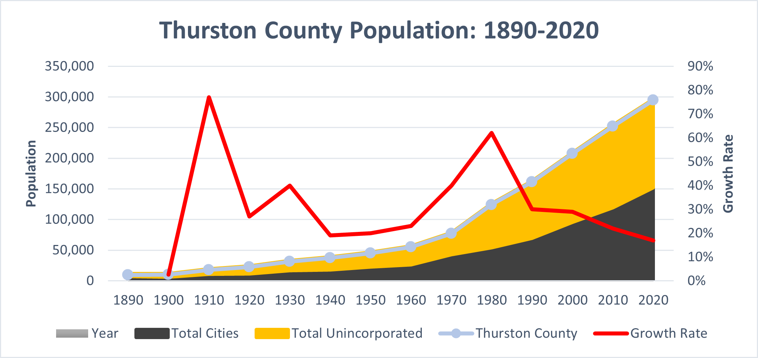
Population in Thurston County has grown steadily since it was formed in 1852 and has been among the fastest growing counties in the state since the 1960s (See Figure 1-2). Unincorporated areas of the county, including urban growth areas, have consistently made up around half of the total population of Thurston County. Although the rate of growth has slowed since 1980, overall population has more than doubled, increasing by an average of 4,500 new residents each year since 1990.
Figure 1-2. Thurston County Population: 1890-2020
Source: U.S. Census Bureau; Washington State Office of Financial Management
Most of the County’s population growth is due to in-migration, and most new residents settle in cities and urban growth areas, which have seen the highest rates of growth.
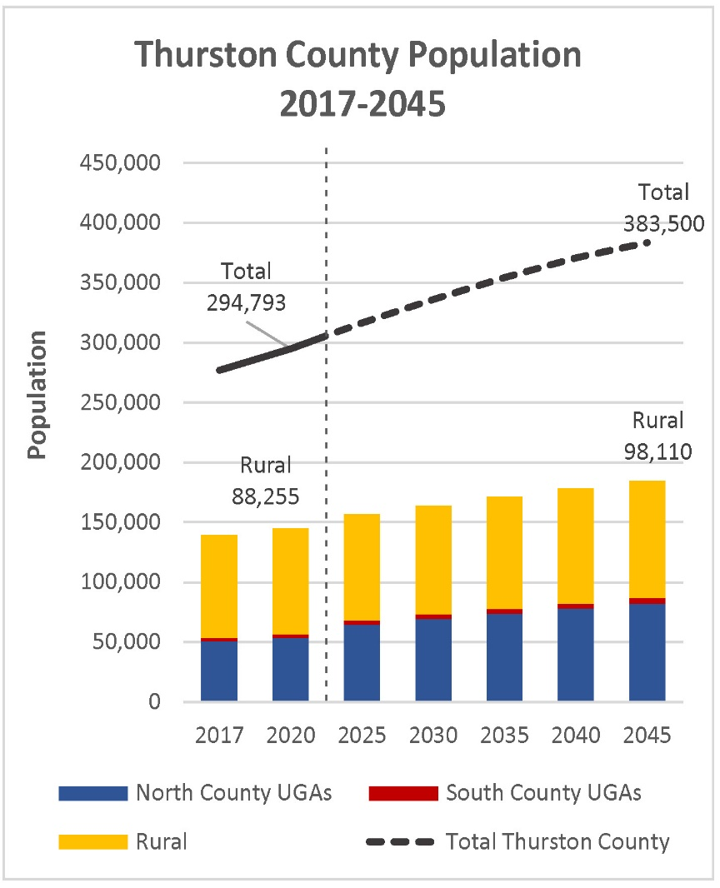
In 2020, Thurston County’s population was approximately 294,793. Projections show more than 383,500 people living in the county in the year 2045, an increase of 30 percent (see Figure 1-3). Just over half of that growth is projected to be in the cities, with another third estimated for the unincorporated urban growth areas. Approximately 12 percent of population growth is estimated to be in the rural parts of the county.
Thurston County’s population is highly educated – greater than 94 percent of residents graduate high school, and more than a third go on to earn a bachelor’s degree or additional graduate work. The presence of Joint Base Lewis-McChord has a strong effect on Thurston County, and 9 percent of the County’s residents are veterans. Approximately 8 percent are foreign-born, and 12 percent of residents speak a language other than English at home – Spanish, Vietnamese, Korean, Tagalog, German, and Hindi are among the most spoken foreign languages.
Figure 1-3. Thurston County Projected Population: 2015-2045
Source: Thurston Regional Planning Council (TRPC) Population & Employment Forecast, 2019

- Chapter 2 – Land USe describes population growth trends in urban and rural areas of the county
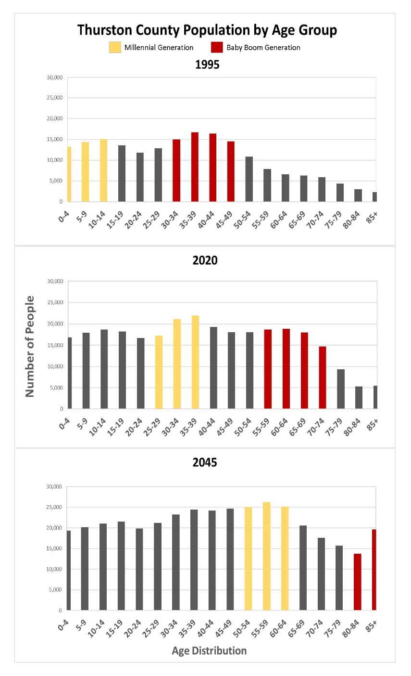
Thurston County has a slightly older population than Washington state overall; preparing for and responding to an aging population will be a major trend over the 20-year planning period. Figure 1-4 shows how Thurston County’s population is distributed by age at three points across a 50-year time span: 1995, 2020, and 2045. The Baby Boom generation (those born between 1946 and 1965), who were in their 30s and early 40s when the Growth Management Act was passed, are already in or entering retirement, while the Millennial generation (roughly, those born between 1980 and 1995) are in or entering their prime working years. Net migration of working-age people moving into Thurston County, rather than the natural increase of current residents (births minus deaths), has helped to fill out the age curves.
In 2045, a child born in 2025 will be in his or her 20s, entering the workforce, starting a family, looking to buy a first home; Millennials will be in their 50s to mid-60s and today’s mid-career professionals (in their 40s) will be retired, while Baby Boomers will be over 80. The proportion of residents aged 65 or older is projected to increase to nearly a fifth of the population by 2045, while growth among age groups of prime working age is projected to slow.

C. Income & Economy
Thurston County’s median household income was $83,358 as of 2022. While this is a 38 percent increase from 2010, Thurston County’s average income has been less than that of the Washington State as a whole consistently since 2015 (see Figure 1-5). The statewide household income trend has been driven by a dramatic increase in wages in King County, in response to growth of the tech sector.
Figure 1-4. Thurston County Population by Age Group: 1995, 2020, 2045
Source: U.S. Census Bureau, OFM, TRPC Population & Employment Forecast, 2019
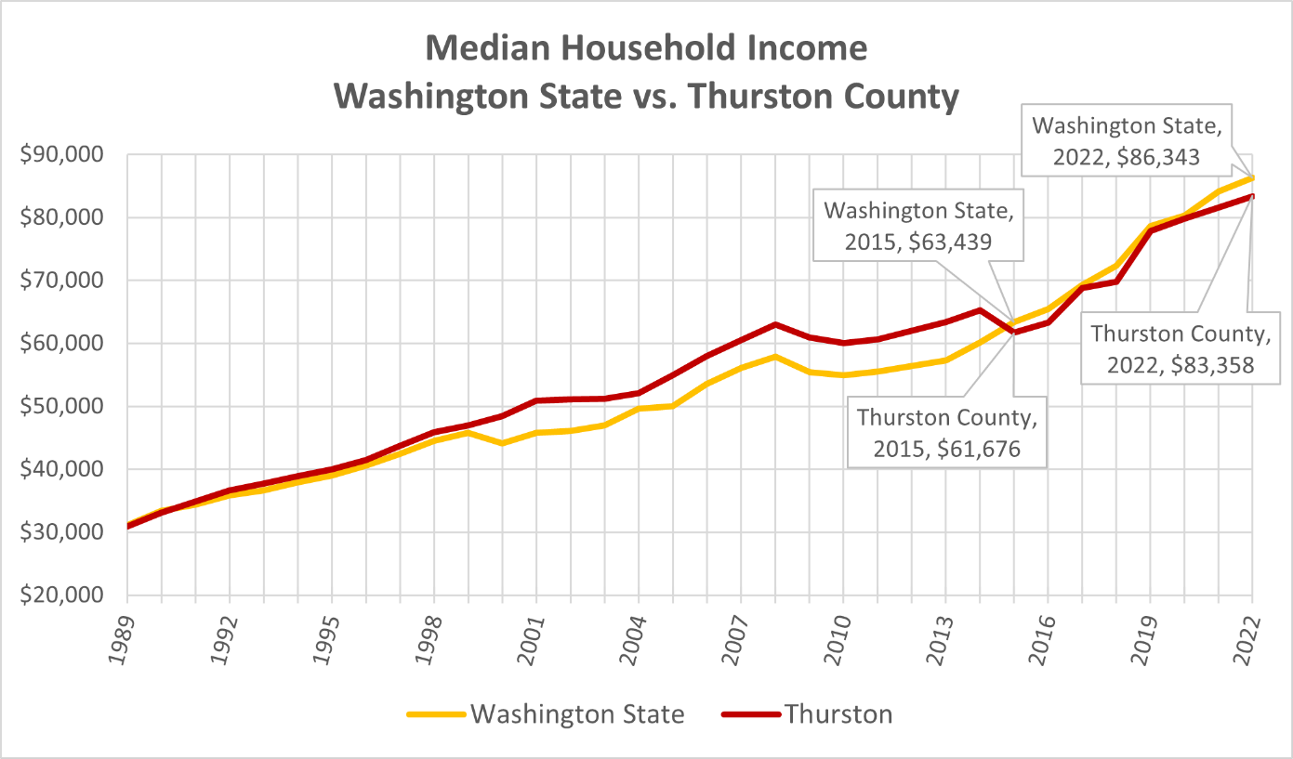
Figure 1-5. Median Household Income: 1989-2022
Source: Washington Office of Financial Management; US Census Bureau

Thurston County has the seventh-highest median household income of all counties in Washington State, falling behind King, Snohomish, Kitsap, Pierce, Clark, and Franklin counties, but ahead of Mason and Lewis counties. This geographic variation in income can be paired with a comparison of relative cost of living (see Figure 1-6). Thurston County has a lower cost of living than many of the counties to its north along the Interstate-5 corridor, particularly when it comes to housing costs. This trend has driven some of the migration into the county; since 2010, the largest source of residents moving into Thurston County are from the Seattle, Bellevue, and Tacoma areas, many of whom are attracted by the lower cost of living.

- Chapter 8 – Economic Development Covers county economic trends
- Chapter 4 – Housing discusses housing affordability
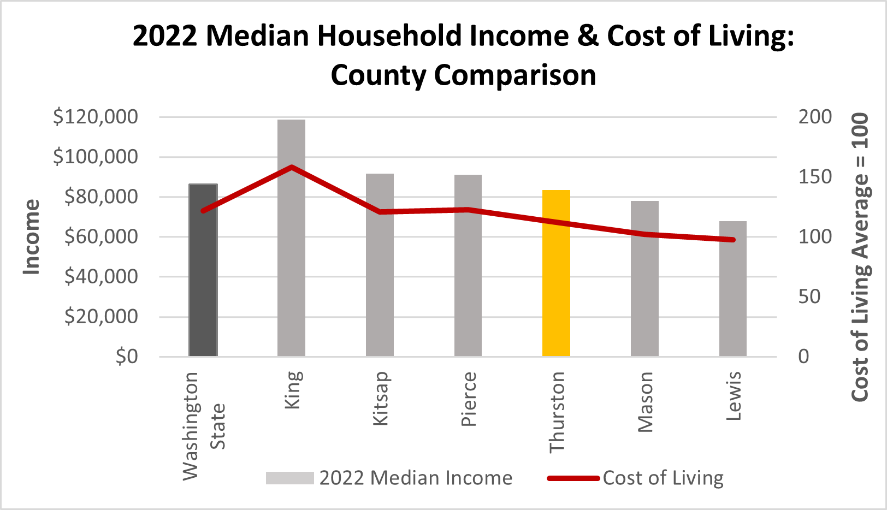
Figure 1-6. Median Income and Cost of Living, County Comparisons
Source: Washington Office of Financial Management; Sperling’s Best Places, 2023
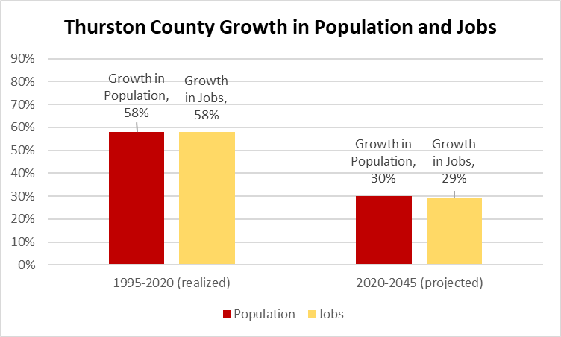
Although lower cost of living may be a factor in Thurston County’s population growth, job growth may also play a factor, though it is projected to slow in the upcoming planning period. Between 1995-2020 the population and jobs within Thurston County grew at the same rate (58%). Between 2020-2045, the population and job growth are projected to slow, but stay relatively close at 30 and 29% (see Figure 1-7). Higher wages and increased job opportunities in the counties and cities to the north lead to more people living in Thurston County and commuting out-bound to employment elsewhere than in-bound commuters.
Figure 1-7. Comparison of Thurston County Population and Job Growth: 1995-2020 and 2020-2045
Source: TRPC Population & Employment Forecast, 2019
Income levels vary within Thurston County. According to the 2017 to 2021 American Community Survey, residents of Rainier ($88,036) and Yelm ($83,027) have the highest median incomes, while Tenino ($55,202) has the lowest (see Figure 1-8).
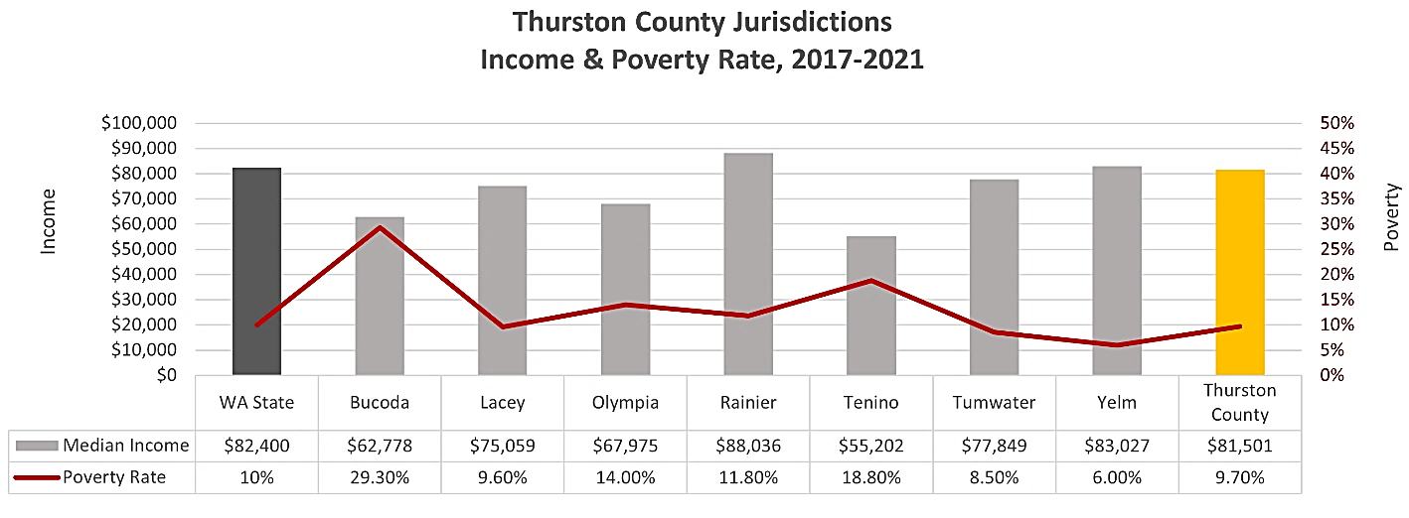
Figure 1-8. Thurston County Jurisdictions, Income and Poverty Rate: 2017-2021
Source: US Bureau of the Census, American Community Survey
The average incomes in the County have gone up while the poverty rate has decreased 2.3 percent, from 12 percent in 2016 to 9.7 percent in 2021. Geographically, low-income families and individuals live throughout the county, but are most concentrated in the areas around Bucoda, Tenino, Rochester, and west Olympia.

In Thurston County, approximately 42,476 people live with a disability. A person with a disability is defined as: “a person who has a physical or mental impairment that substantially limits one or more major life activities.” Of these individuals, U.S. Census Data shows that in 2021, 43 percent were 65 years of age or older and 16 percent had incomes that were below the poverty level.
Poverty rates are also higher than average among minority groups, including American Indian and Alaskan natives (25 percent), Blacks (19 percent), and Hispanics (16 percent). The housing cost in Thurston County for those who rent is on average 30 percent of the median income and for those with a mortgage is 22 percent the median income.
◼
Considering the combination of trends described above – including rapid population growth, an aging general population, increased income disparity, and climate change – Thurston County is likely to continue to undergo dramatic change over the next several decades. The background information, goals, and policies included in this Comprehensive Plan are intended to help the county prepare for and address these changes, and achieve the community’s vision, while protecting the qualities people value about Thurston County to ensure they are available to future generations.

2019/2020 Thurston County Strategic Plan.
Thurston Regional Planning Council, Population & Employment Forecast, 2019
2022 U.S. Census Bureau QuickFacts for Thurston County, Washington. Accessed November 21, 2023.
Washington State Office of Financial Management; U.S. Census Bureau, American Community Survey
Housing and Urban Development 2020 Comprehensive Housing Market Analysis
Americans with Disabilities Act https://adata.org/faq/what-definition-disability-under-ada

