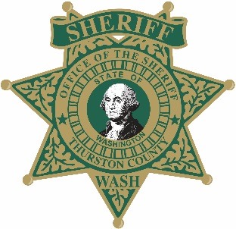
Thurston County Sheriff’s Office
Vacation House Check Form

Address:
Community or personal gate code:

Date Leaving: Date Returning: Limited to 30 days

Homeowner (full name):
Home phone #: Mobile phone #
Email address:

Local emergency contact person (first & last):
Does this person have your house key? Yes No
Home phone #:
Mobile phone #:
Person with keys or access:
Home phone #: Mobile phone #:
Have the following been addressed? (Circle those that apply to your home)

Mail stopped: Yes No Timer lights set: Yes No
Check mailbox: Yes No Hours timer set:
Newspaper stopped: Yes No House Alarmed: Yes No
Car left in driveway: Yes No Alarm Co.:
Alarm Co. Phone:

Vehicle Description:(Yr. / Make / Model) Vehicle License:

Pet/s in home or property? Yes No Type of pet:
Other information:

I , grant permission to the Thurston County Sheriff’s Office to come onto my listed property to conduct a premise check. I understand this service is limited to a 30-day period and if my vacation lasts longer, I will seek other resources. Furthermore, I understand TCSO is not promising a daily check of my property and I agree to hold TCSO harmless of any loss/damage.

By typing the name below, I acknowledge the above statement.
Signature: Date:

DO NOT COMPLETE THIS PAGE - For Sheriff’s Office Official Use only

Date | Time | Initials | Initials |  | Date | Time | Initials | Initials

DO NOT COMPLETE THIS PAGE - For Sheriff’s Office Official Use only

