COUNTY COMMISSIONERS
Carolina Mejia-Barahona District One
Gary Edwards District Two
Tye Menser
District Three

COMMUNITY PLANNING & ECONOMIC DEVELOPMENT DEPARTMENT

Creating Solutions for Our Future Joshua Cummings, Director

THURSTON COUNTY COMMUNITY
COMMUNITY PLANNING & ECONOMIC DEVELOPMENT REPORT HEARING EXAMINER HEARING
November 14th, 2023

PROJECT NO.: 2022105705

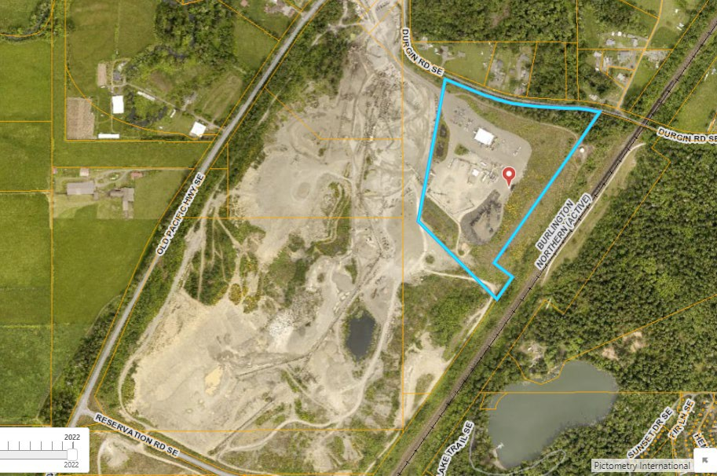
SEQUENCE NO.: 2022 115152 ZM Special Use Permit SEQUENCE NO.: 2022 115154 XA SEPA

REQUEST:

The Applicant seeks to amend their Special Use Permit to allow for asphalt recycling at the existing Durgin Road Asphalt Plant. Project also proposes to store 8,800 cubic yards of reclaimed asphalt product on site at any given time within a 15,383 square foot covered structure. The property is zoned RR 1/5 Rural Residential in Thurston County.

GENERAL INFORMATION

- Applicant: LAKESIDE INDUSTRIES Atten: Kyler Danielson
PO Box #7016
Issaquah, WA 98027 kyler.danielson@lakesideindustries.com

- Location: 11125 Durgin Rd. SE, Olympia, WA 98513

- Legal Description: Section 17 Township 18 Range 1E Quarter SW NE NW SE
BLA980097 TRB Document 3151588

- Land Area: 24.98-acre parcel size

3000 Pacific Ave SE, Olympia, Washington 98501 (360) 786-5490/FAX (360) 754-2939 TTY/TDD call 711 or 1-800-833-6388 Website: www.co.thurston.wa.us/permitting

PROJECT DESCRIPTION

The applicant has stated that their “state-of-the-art” asphalt plant at Durgin Rd. does not currently reprocess asphalt. However, the recent amendment of the Nisqually sub area plan allows asphalt recycling and reclaimed asphalt product (RAP) stockpiles if they are covered. The Applicant requests to amend their existing Special Use Permit (SUP) to allow for recycling asphalt material and the storage of RAP under a cover structure at their existing asphalt plant (Attachments B & C). The intention of the current application is to store approximately 8,800 cubic yards of RAP on site under a 15,383 square foot storage structure, which is proposed to be approximately 37-feet in height. RAP will be imported from paving projects throughout the region.

The new cover structure and RAP would be situated in the east area of the site on paved surface with no significant vegetation near the existing asphalt plant, which is accessory to an existing mining operation operated by Holroyd Co. in the ‘Nisqually Sub Area’. No new impervious surfaces are proposed. The RAP would be added to asphalt mixes during asphalt mix manufacturing. Access to the asphalt plant will be by way of an existing driveway from Old Highway 99 SE. Employees will use existing facilities located within an existing office building.

Thurston County code requires review of approved mineral extraction and accessory use permits no less often than every five years (TCC 20.54.070(3.1)).

BACKGROUND

The asphalt plant was originally approved by the Hearing Examiner on April 20, 2001 with Special Use Permit Number 990457. The 5-year review was recently approved on July 1, 2021. (Attachment – H)

The project is in the Rural Residential – One Dwelling Unit Per Five Acres Zoning District (RR 1/5), within the rural designated part of the County. Asphalt plants are allowed in the RR 1/5 zoning district as an accessory to a mineral extraction use, subject to obtaining a Special Use Permit [TCC 20.54.070(3.1)].

The underlying property is mapped with soil types that are considered possible locations for native prairie habitat and certain protected species, including the Mazama pocket gopher. The gopher is listed as Threatened under the federal Endangered Species Act. As an existing gravel extraction, mine, all the topsoil has been removed, thereby removing potential habitat. The site is mapped as a category 1 critical aquifer recharge area, which is a critical area regulated by the County Critical Area Ordinance (TCC 24.10). No other critical areas were identified on the property.

[Please Note: Attachments – H, L, and S provided for additional project background.]

VICINITY & ZONING
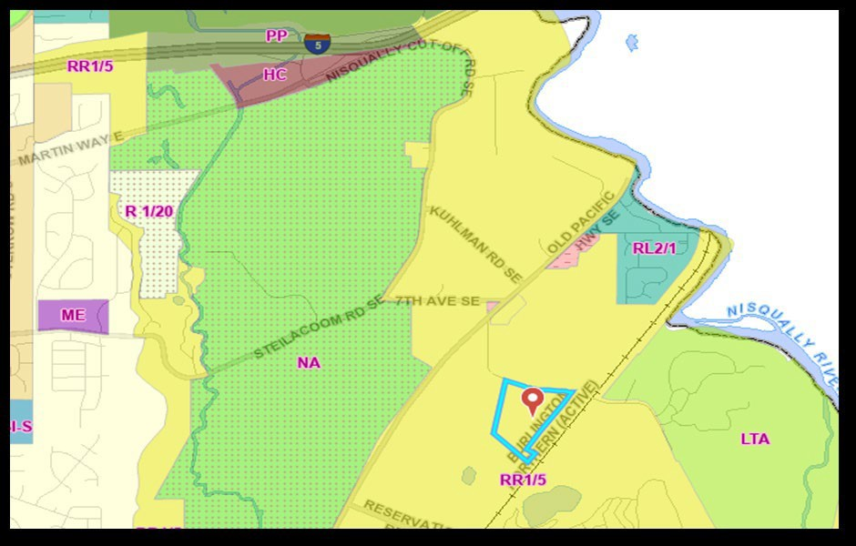

NOTIFICATION

Written Notice of Application was first sent to interested parties and properties within 2,600-feet on January 25, 2023. Notice of the public hearing was posted to the site and published in The Olympian on (or before) November 3, 2023, at least ten (10) days prior to the hearing.

ENVIRONMENTAL EVALUATION

A SEPA Determination of Non-Significance’ (DNS) was issued for the current application on September 29, 2023. (Attachment - G) The decision was not appealed.

DEPARTMENT ANALYSIS

Zoning (TCC 20)

The Rural Residential – One Dwelling Unit Per Five Acres Zoning District (RR 1/5, TCC 20.09) allows certain primary uses (TCC 20.09.020) and Special Uses (TCC 20.09.025). Potential special uses are listed in Chapter 54 of the Zoning Ordinance (TCC 20.54), Table-
  - The potential Special Uses include asphalt production as an accessory use to a mineral extraction use [TCC 20.54.070(3.1)]. Additional analysis provided below.

Section 20.09.040 - Design standards (TCC). The following standards are established as the minimum necessary to ensure that the purpose of this rural residential, one unit per five-acre(s) district is achieved and maintained as new lots are created and new buildings are constructed:

- Minimum Lot Size:
  - Conventional subdivision lot (net) - four acres for single-family, eight acres for duplexes;

Staff Response: This standard is not applicable.

  - Nonresidential use—five acres;

Staff Response: This standard is met. The project site is approximately 25-acres.

- Maximum Building Height—thirty-five feet;

Staff Response: The current proposed shed structure is a required appurtenance to the existing, ongoing operation, and may be considered excluded from maximum height regulations as an “…other similar structures and mechanical appurtenances.”; such as: barn, silo, dome, etc. (Sec. 20.07.080 – TCC).

- Minimum Yard Requirements: See Section 20.07.030;

Staff Response: This standard is met. Minimum setbacks from property lines for commercial/industrial structures is a minimum setback from side and rear property lines is 10-feet. The minimum setback from the front line is 35-feet. The proposal complies with these standards.

- Maximum Coverage by Hard Surfaces. Maximum hard surface coverage for new development in this district is as follows (also see Chapter 20.07):

  - Lots two and one-half acres or greater: Ten percent.

Staff Response: This standard is not applicable.

  - Lots less than two and one-half acres: Sixty percent or ten thousand square feet, whichever is less.

Staff Response: This standard is not applicable.

Use – Specific Standards [TCC 20.54.070(3.1)]

- Setbacks. The emissions point source at an asphalt plant shall be separated by a distance of at least five hundred feet from public parks and public preserves, which include parks, regional trails, national wildlife refuges, state conservation areas, wild life areas, and other government owned preserves, or three hundred feet from the boundary of any

residential zoning district with an existing or zoned density of greater than one dwelling unit per five acres, urban growth areas, and any residential lot less than one acre in size.

Staff Response: This standard is met. There are no government owned or provided amenities within 300’. Nor is there any residential parcel within the residentially zoned district within 300’ less than one acre in size or having a residential density greater than one dwelling unit per 5-acres.

- Asphalt plants are allowed in the rural resource industrial (RRI), light industrial (LI), and rural residential resource one dwelling unit per five acres (RRR1/5) zoning designations or within a permitted gravel mine located within selected zoning designations as reflected in Table 1. Existing asphalt plants located within a permitted mineral extraction use area may apply for a new special use permit when the extraction activity ceases.

Staff Response: This standard is met. The property is situated within designated mineral lands having commercial significance and has a legally established mining operation and asphalt plant.

- The location of asphalt plants shall be consistent with the Thurston County Comprehensive Plan, which includes, but is not limited to, sub-area plans.

Staff Response: This standard is met. The existing operation and proposed use are consistent with both the Comprehensive Plan, and Nisqually sub-area plan.

- Prior to commencing operation, the asphalt plant operator shall provide evidence to the county that the facility has received coverage under the state's National Pollution Discharge Elimination Systems (NPDES) general permit applicable to asphalt plants, unless it provides written confirmation of an exemption from the agency with jurisdiction over such permit.

Staff Response: This standard is met. The asphalt plant is not new to the site and is an ongoing commercial activity. In addition, the applicant recently received their 5-year review.

- Asphalt plants shall provide necessary space to accommodate delivery trucks on the site.

Staff Response: This standard is met. The applicant has stated that RAP material will be imported from paving projects throughout the region Lakeside provided a Traffic Trip Generation Memo, which is included as Attachment N to this Staff Report.

- Asphalt plants shall have County approved haul routes.

Staff Response: This standard is met. No changes to existing routes are proposed.

- The source of recycled asphalt pavement (RAP) shall only be from highways, roadways, runways, parking lots and shall not be from a contaminated site such as a superfund site or Model Toxic Control Act (MTCA) site. The asphalt plant operator shall provide semiannual reports to the county documenting the source of all recycled asphalt pavement brought to the production site.

Staff Response: This standard is met. The RAP proposed to supply this application will be imported from paving projects throughout the region. Lakeside has stated in its SUP Application Project Description that it has a policy prohibiting acceptance and import of RAP from industrial or commercial hazardous material storage sites or sites undergoing cleanup action. The site is currently subject to review every 5-years to maintain required operational permit. Staff asks that applicant speak to this requirement for a more comprehensive description of how this is met.

- Asphalt plants shall comply with the requirements and best management practices of the Thurston County Drainage Design and Erosion Control Manual, as amended.

Staff Response: This standard is met. This requirement will also be made a project condition.

- Asphalt plants shall be fueled by natural gas, propane, or an alternative fuel with the same or less hazardous emissions or waste as natural gas or propane.

Staff Response: This standard is met. The current application does not propose to add mechanical equipment necessitating fuels. However, Staff asks that applicant speak to this requirement for a more comprehensive description of how this is met.

- The operation shall obtain and maintain a solid waste permit from Thurston County environmental health for operations that recycle asphalt.

Staff Response: This standard is met. Staff asks that applicant speak to this requirement for a more comprehensive description of how this is met, but this will also be made a project condition.

- Asphalt plants shall meet all applicable requirements of Chapter 17.20 TCC, Mineral Extraction and Asphalt Production.

Staff Response: This standard is met. The plant’s operation is existing and subject to periodic review at the site level. This current request is limited to the storage, cover, import, and processing of RAP material on site. Staff asks that applicant speak to this requirement for a more comprehensive description of how this is met.

- For operations that process and store recycled asphalt pavement (RAP) within the Nisqually subarea, operators shall employ best management practices to mitigate leachate by providing covered storage of processed/recycled asphalt stockpiles. Specific practices will be determined through the site-level permit review process, but may include tarping, storage sheds, or other methods.

Staff Response: This standard is met. The current RAP material is covered by tarps. A part of the applicant’s request is to construct a 15,383 square foot storage shed. (Attachment - D)

Commenting Agencies

Washington State and Thurston County review agencies have submitted their comments and recommendations, which are attached (Attachments U through Z and BB) and made part of this report.

- Email submitted by the Squaxin Island Tribe, dated February 2, 2023 (Attachment - U) stating no concerns.
- Email from the Olympic Region Clean Air Agency (ORCAA) in response to SEPA, dated February 6, 2023. (Attachment - V)
- The Washington State Department of Ecology submitted a comment letter, dated February 16, 2023, and reaffirmed October 12, 2023 (Attachment - W)
- Email from Community Planning & Economic Development Hydrogeologist, Kevin Hansen, dated August 1, 2023 (Attachment - Y)
- Memorandum from Public Works, (Arthur Saint) “Recommendation for Approval” with conditions, dated July 31, 2023 (Attachment - Z)
- Memorandum from Environmental Health (Dawn Peebles) “approval of the project is hereby recommended with … conditions”, dated November 6, 2023 (Attachment - BB)

Public Comment

Attached (Attachment - AA)

DEPARTMENT RECOMMENDATION

If the Hearing Examiner grants approval to amend Special Use Permit # 990457, then based on the above analysis, the Community Planning and Economic Development Department recommends the following conditions:

- Specific recommended conditions as follows:

  - Comments submitted by Olympic Region Clean Air Agency (ORCAA), dated February 6, 2023, “Attachment - V” should be incorporated by reference and made conditions of .
  - Comments provided by the Washington State Department of Ecology, dated February 16, 2023, “Attachment - W” should be incorporated by refence as conditions.
  - Public Works, “Recommendation for Approval” dated July 31, 2023, with conditions “Attachment - Z” should be incorporated by reference.
  - Environmental Health, “Recommendation for Approval” with recommended conditions, dated November 6, 2023 “Attachment – BB” should be incorporated by reference.

- Applicant is responsible for compliance with other jurisdictional permitting requirements.

- The applicant shall remove all debris related to construction of the RAP cover to an approved site (landfill or recycling center) outside of subject property.

- A Construction Stormwater Permit from the Washington State Department of Ecology may be required. It is the applicant’s responsibility to obtain this permit if required. Information about the permit and the application can be found at: http://www.ecy.wa.gov/programs/wq/stormwater/construction/permit.html.
[As noted above, the Department of Ecology’s recommendations, submitted February 16, 2023 (Attachment - W) has been requested to be incorporated as conditions of approval.]

- Construction fencing and erosion control shall be inspected prior to building permit issuance. Best management practices (BMPs) such as maintaining proper working order of equipment, as well as temporary erosion and sediment control (TESC) methods including silt fencing and/or coir logs shall be implemented and remain in place during the entire course of construction.

- Approval of this and other County permits may be superseded by federal law. If any protected species are found during construction, the applicant should contact the U.S. Fish and Wildlife Services.

- The Applicant must comply with all requirements of state and/or federal law to avoid disturbance and alteration of artifacts, remains, or other cultural resources on site during development. In the event of inadvertent disturbance or alteration, the Applicant must immediately stop work and contact the Tribe and the State Department of Archaeology and Historic Preservation.

- All development on the site shall be in substantial compliance with the approved Special Use Permit application as conditioned. Any alteration to the proposal will require approval of a new or amended SUP. The Community Planning and Economic Development Department will determine if any proposed amendment is substantial enough to require Hearing Examiner approval.

Kraig Chalem, Senior Planner
Community Planning and Economic Development

LIST OF EXHIBITS

EXHIBIT 1 Community Planning & Economic Development Report including the following attachments:

Attachment-A Legal Notice, Dated: 11.03.2023 Attachment-B Master Application, Dated: 11.14.2022 Attachment-C Special Use-Application, Dated: 11.14.2022 Attachment-D Site Plan 2022105705, Dated: 11.14.2022 Attachment-E Notice of Application, Dated: 01.27.2023 Attachment-F Current As-Built Plans, Dated: 01.15.2008
Attachment-G SEPA DNS Lakeside Asphalt-Project, Dated: 09.29.2023
Attachment-H Hearing Examiner Decision project #2019102295, Dated: 07.01.2021 Attachment-I Pocket Gopher Report, Dated: 07.13.2022
Attachment-J Email from County Accepting Trip Generation Report 09.13.2022 Attachment-K SEPA Checklist
Attachment-L Superior Court Final Order, Dated: 07.08.2002 Attachment-M Noise Monitoring Plan, Dated: 09.21.2022 Attachment-N Traffic Trip Generation Memo, Dated: 09.21.20220 Attachment-O Drainage Report, Dated: 11.14.2022
Attachment-P Durgin Rd. RAP Cover Letter, Dated: 11.14.22
Attachment-Q Groundwater Monitoring-Sampling Results, Dated: 10.14.2022 Attachment-R Interim Cover Letter Update, Dated: 06.26.2023
Attachment-S Lakeside Court of Appeals Mandate, Dated: 11.9.2004 Attachment-T Final Agreed Condition Language, Dated: 06.02.2021 Attachment-U Squaxin Island Tribe Comments, Dated: 02.02.2023 Attachment-V ORCAA comments, Dated: 02.06.2023
Attachment-W Ecology Comments, Dated: 02.16.2023 Attachment-X Ecology Comments, Dated: 10.12.2023
Attachment-Y Kevin Hansen Hydrogeologist Comment, Dated: 08.01.2023 Attachment-Z Public Works Recommendation of Approval, Dated: 07.31.2023 Attachment-AA Public Comments
Attachment-BB Environmental H. Recommendation of Approval, Dated: 11.06.2023

